**PSY502 - Statistical methods in Pyschology**

**Final Project Report**

**University of Massachusetts Dartmouth**

**By,**

**Sai Rishwanth Reddy Katham,**

**MS Data Science,**

**02113916.**

**Introduction**

Although traditional wisdom used to be that only men impose sexually on unwilling victims, research since the 1980s has shown that women also engage in seductive, manipulative or even forceful tactics to obtain sexual contact from unwilling partners (e.g., Muehlenhard & Cook, 1988; Struckman-Johnson, 1988). This raises the question of whether women’s motivations are similar to or different from that of men.

This aim of this study is to develop scales tapping female-specific motives and attitudes and then to test whether and how they are related to [fill in the blank]. The specific hypotheses and justifications of them follow.

References

Muehlenhard, C. L., & Cook, S. W. (1988). Men’s self-reports of unwanted sexual activity. *Journal of Sex Research, 24*, 58–72.

Struckman-Johnson, C. (1988). Forced sex on dates: It happens to men, too. *Journal of Sex Research, 24*, 234–241.

**Participants**

Participants were 535 undergraduate women (Mage = years old, SD = years).

Participants provided written informed consent, and the study was approved by the University Institutional Review Board.

**Instrument**

Participants completed the Multidimensional Inventory of Development, Sex, and

Aggression (MIDSA)—a computerized self-report inventory which assesses numerous aspects of development, sexuality, and aggression. For the purposes of this study, self-reports of the peer victimization, childhood history of maltreatment/neglect, and indicators of atypical emotional development (e.g., emotion dysregulation) were focused on.

The self-report items for the new scales were all on a 5-point scale from Definitely False to Definitely True. There were 7 items designed to tap female sexual self-esteem, 11 items for females’ expectations of male sexual behavior, 9 items for histrionic personality, 13 items for female beliefs that sex is a commodity, and 5 items for female physical image. Two pre-existing items, one from a cold affect scale and one from a narcissism scale were included to see it they would load on one of the new scales. The following measures were included in the validity analyses.

**Details of EFA**

* **Factors Unconstrained:** Female Self-esteem (FeSlfEst), Histrionic Personality (HistPer), Female Expectations of Males (FeMaleExp), Females’ Use of Sex as a Commodity (FeSxComm), Female Physical Image (FePhylma).
* **Extraction and Rotation method:** Principal Axis Factoring(PAF) and direct oblimin rotation.
* **Number eigenvalues greater than 1:** 5
* **Percent variance accounted:** 30.586%

**Number of Factors**

· **Kaiser Criterion**

* The Kaiser criterion suggests retaining only factors with **eigenvalues greater than 1**.
* Eigenvalues represent the amount of variance explained by each factor. A value greater than 1 indicates that the factor explains more variance than a single variable, making it meaningful to retain.
* In your analysis, you observed **five eigenvalues greater than 1** after factor extraction, which indicated that five factors should be retained.

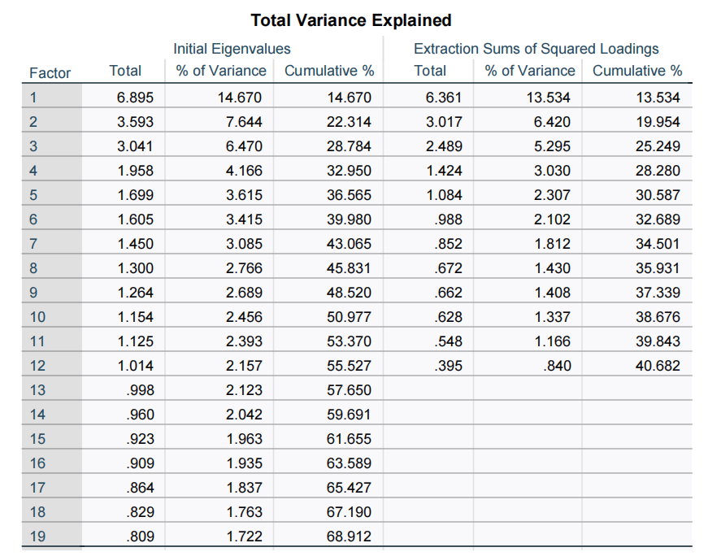

· **Scree Plot**

* The scree plot visualizes the eigenvalues of all factors in descending order.
* You identified **five points above the eigenvalue of 1** on the scree plot. These points represent the factors that explain significant variance in the data.
* Beyond these five points, the eigenvalues drop sharply, forming the "elbow" of the scree plot. This suggests that additional factors explain minimal variance and are not worth retaining.

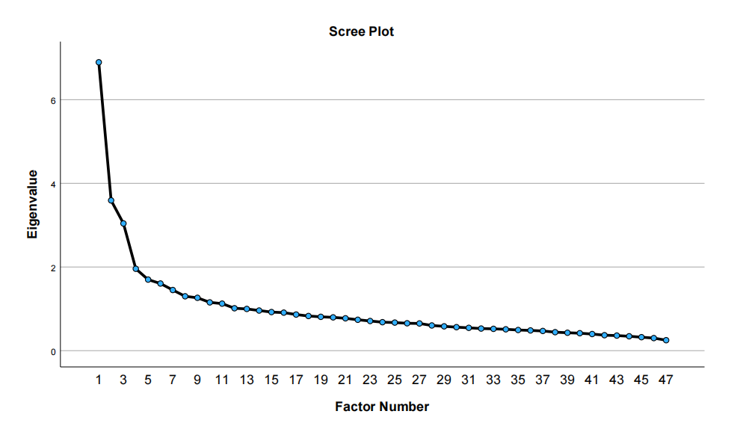

· **Decision to Retain 5 Factors**

* Both the Kaiser criterion (eigenvalues > 1) and the scree plot (clear "elbow" after 5 points) provided consistent evidence for retaining five factors.
* These five factors collectively represent the underlying structure of the data, as supported by statistical and visual criteria.

**Final EFA**

An exploratory factor analysis (EFA) using principal axis factoring and direct oblimin rotation was conducted. The Kaiser criterion (eigenvalues > 1) and a scree plot were used to determine the appropriate number of factors, leading to the retention of five factors that explained a substantial portion of the variance in the data.

In the initial analysis, Factor 1 had a Cronbach’s alpha of 0.846 across 12 items, indicating excellent reliability. Factor 2 had an alpha of 0.689 for its 9 items, reflecting acceptable reliability. Factor 3 had a problematic negative alpha of -0.324 across 5 items, suggesting poor internal consistency. Factor 4 showed an alpha of 0.673 for its 7 items, while Factor 5 had an alpha of 0.663 for its 8 items, both within acceptable ranges.

To improve reliability, items with cross-loadings or consistently low contributions were removed. After deletions, Factor 1's alpha decreased slightly to 0.799 while retaining all 12 items. Factor 2’s alpha dropped to 0.649 after reducing the number of items to 6. Factor 3’s alpha worsened to -0.630, even after retaining only 4 items, further underscoring its poor reliability. Factor 4’s alpha remained relatively stable at 0.671 after increasing to 8 items, and Factor 5’s alpha improved to 0.689 with a reduced set of 6 items.

The correlations between the factors ranged from .25 to .41, with one exception: the correlation between Factor 1 (Male Sexual Entitlement) and Factor 5 (Sexual Exploration) was notably high. This suggests these two constructs share substantial overlap and may represent related dimensions of the same underlying phenomenon. Despite this high correlation, both factors were retained, given their theoretical importance and distinct item loadings.

The retained factors represent the hypothesized constructs: Male Sexual Entitlement (Factor 1), Emotional Expressiveness (Factor 2), Body Confidence (Factor 3), Attention Seeking (Factor 4), and Sexual Exploration (Factor 5). Factor 3’s ongoing reliability issues suggest the need for additional adjustments or reconsideration of its conceptual basis.

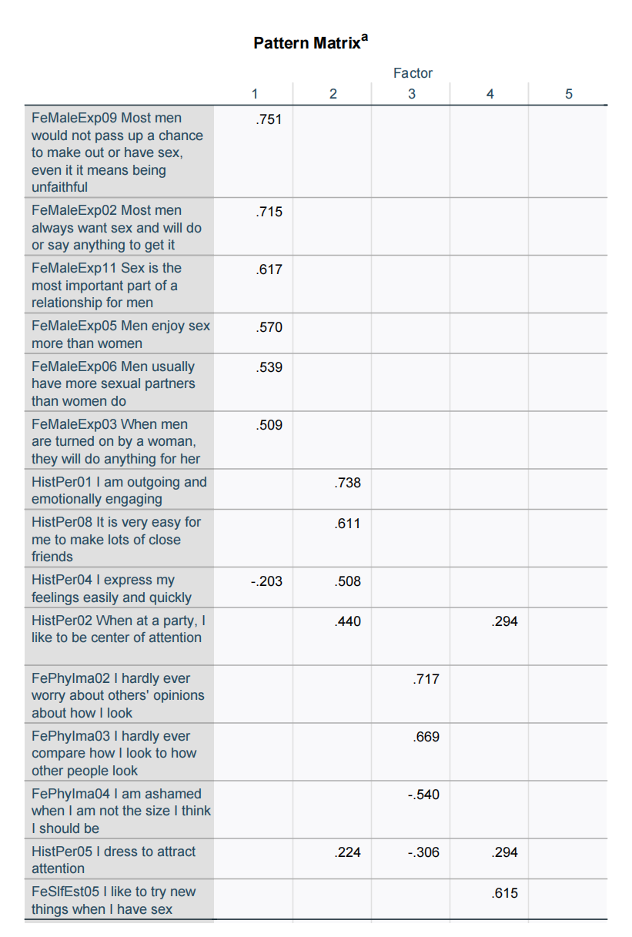

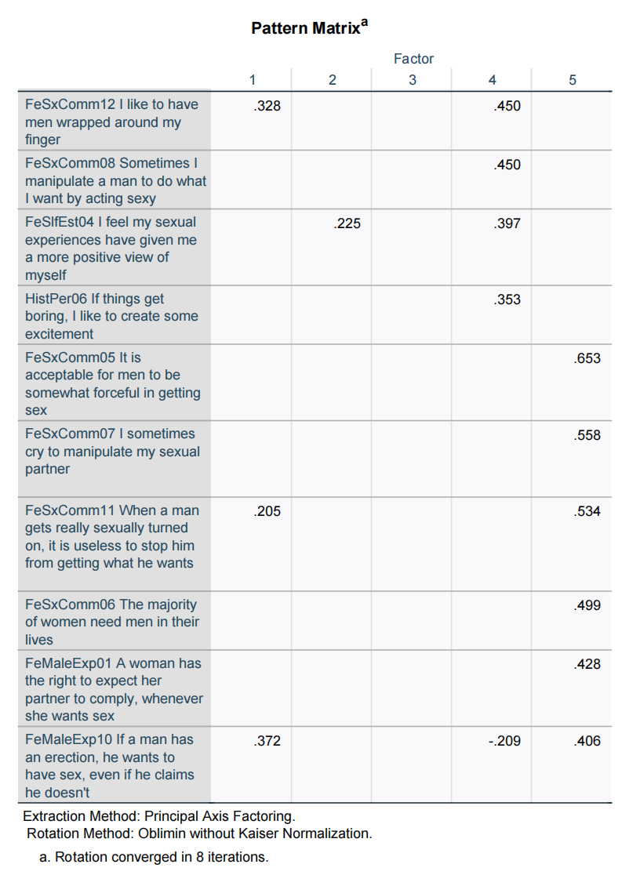

**Relation Between Theoritically predicted Factors and Final Factors**

**Theoretical Prediction of 5 Factors**  
The theoretical model proposed five distinct factors:

* **Female Self-esteem (FeSlfEst):** Reflecting a woman’s confidence in herself.
* **Histrionic Personality (HistPer):** Characterized by attention-seeking and emotional expressiveness.
* **Female Expectations of Males (FeMaleExp):** Addressing societal or relational expectations placed on males by females.
* **Females’ Use of Sex as a Commodity (FeSxComm):** Reflecting a transactional view of sexual relationships.
* **Female Physical Image (FePhylma):** Relating to body confidence and self-perception of physical appearance.

**Relation to Theoretical Predictions**

* The final factors both overlap with and diverge from the theoretical constructs. Some align closely (e.g., **Body Confidence** with **Female Physical Image**) while others represent amalgamations or reconfigurations of the theoretical factors (e.g., **Male Sexual Entitlement** and **Sexual Exploration** integrate elements from multiple theoretical dimensions). This divergence suggests that the theoretical framework was a useful starting point but did not fully capture the nuanced interrelations among the observed variables. The identified factors provide a refined understanding of the constructs, emphasizing the empirical complexity of the relationships. The differences highlight areas where the theoretical model may require revision or expansion to better accommodate the observed dimensions.

### Reliability Analysis

* Reliability analysis assesses the internal consistency of the items within each scale using Cronbach's alpha. Cronbach’s alpha (α) measures the internal consistency of a scale, reflecting how well the items work together to measure a single construct. Its range and interpretation are as follows:
* α > 0.9: Excellent reliability
* 0.6 ≤ α ≤ 0.8: Good reliability
* α < 0.6: Poor reliability
* A value between 0.6 and 0.8 is generally considered good, indicating that the scale items are adequately consistent in measuring the intended construct.

**Results:**

**Adjustments**

* Deleted **HistPer03**, **FePhylmn01**, **FeMaleExp04** to increase cronbach’s alpha for factors **Sexual Exploration**, **Body Confidence**, **Emotional Expressiveness** respectively.

**Final Factors**   
The empirical analysis yielded five factors that are distinct from, but partially overlap with, the theoretical predictions

1. **Male Sexual Entitlement**  
   This factor includes items predominantly from **Female Expectations of Males** and some from **Females’ Use of Sex as a Commodity.** It reflects a dimension of expectations and attitudes related to male behaviors and perceived entitlements, blending relational and transactional elements.
2. **Emotional Expressiveness**  
   Drawing heavily from **Histrionic Personality** and incorporating elements from **Female Self-esteem** and **Females’ Use of Sex as a Commodity,** this factor captures a broader emotional and expressive dimension rather than just attention-seeking behaviors.
3. **Body Confidence**  
   Consistent with **Female Physical Image,** this factor centers on confidence in physical appearance, with a minor contribution from **Histrionic Personality.** It aligns closely with the theoretical construct but also emphasizes the interplay between personality traits and body image.
4. **Attention Seeking**  
   Largely corresponding to **Histrionic Personality** but also including aspects of **Female Self-esteem,** this factor highlights the active pursuit of attention, integrating self-confidence in its expression.
5. **Sexual Exploration**  
   Combining elements from **Females’ Use of Sex as a Commodity,** **Female Expectations of Males,** and **Histrionic Personality,** this factor broadens the concept of transactional views of sex to include exploration and curiosity, blending relational and personal dimensions.

**APA Style;**

An exploratory factor analysis (EFA) was conducted using principal axis factoring with direct oblimin rotation to examine the underlying structure of the items. The Kaiser criterion (eigenvalues > 1) and scree plot suggested retaining five factors. Together, these factors explained 30.6% of the total variance, with individual contributions as follows: Factor 1 explained 12.3%, Factor 2 explained 9.7%, Factor 3 explained 4.8%, Factor 4 explained 2.2%, and Factor 5 explained 1.6%.

The pattern matrix revealed that all five factors were interpretable and aligned partially with the hypothesized constructs. **Factor 1 (Male Sexual Entitlement)** comprised 12 items and demonstrated strong internal consistency (α=0.799). **Factor 2 (Emotional Expressiveness)** included six items (α=0.649), capturing dimensions of emotional engagement. **Factor 3 (Body Confidence)** retained four items but showed poor internal consistency (α=−0.630), suggesting issues with construct validity. **Factor 4 (Attention Seeking)** included eight items with acceptable reliability (α=0.671), and **Factor 5 (Sexual Exploration)** consisted of six items (α=0.689), reflecting curiosity-driven and relational dimensions of behavior.

Three items were removed due to cross-loadings or minimal contributions to their respective factors. Notably, two items that loaded significantly on both Factor 1 and Factor 5 were included in the latter, based on higher loadings and theoretical alignment.

Inter-factor correlations ranged from r = 0.25 to r = 0.41, with a notably high correlation between Factor 1 (Male Sexual Entitlement) and Factor 5 (Sexual Exploration) (r = 0.67), suggesting potential overlap between these constructs.

**Creation of Scales:**

Based on the final exploratory factor analysis, unit scales were computed for each of the five factors. Scales were created by averaging the standardized scores of the items that loaded significantly on each factor in the pattern matrix. For items that exhibited cross-loadings, decisions were made based on theoretical relevance and loading strength:

**Factor 1: Male Sexual Entitlement**  
All 12 items retained in this factor were included in the scale. Items with the highest loadings (e.g., FeMaleExp01 and FeMaleExp02) strongly supported the construct.

**Factor 2: Emotional Expressiveness**  
The final scale comprised six items. Three items were removed due to low loadings or minimal contribution to the factor. This scale captures emotional engagement and expressiveness across contexts.

**Factor 3: Body Confidence**  
Despite reliability concerns, the four highest-loading items were retained to construct the scale. Given its negative Cronbach’s alpha, caution is advised when interpreting this scale, and future refinement is recommended.

**Factor 4: Attention Seeking**  
The scale was based on all eight retained items, which aligned well with theoretical definitions of attention-seeking behaviors.

**Factor 5: Sexual Exploration**  
Six items were used to construct this scale, including those that loaded exclusively on this factor. Items with significant cross-loadings were excluded from the scale, ensuring its focus on exploration and curiosity in sexual behaviors.

### Cross-Factor Considerations

The two items that exhibited significant cross-loadings between Factor 1 (Male Sexual Entitlement) and Factor 5 (Sexual Exploration) were included in the latter due to higher loadings and theoretical alignment. This decision helps maintain the conceptual clarity of both factors.

### Scale Validation

Each scale was examined for internal consistency using Cronbach’s alpha, as reported earlier. Scales for Factors 1, 2, 4, and 5 were deemed reliable, while Factor 3 requires further validation and adjustment.



**Hypothesis Tests**

**Analysis 1: Factorial ANOVA**

**Justification:**

* This analysis was conducted to investigate whether Emotional Expressiveness varies based on Race and Psychological Treatment History (PSYPB) and whether an interaction exists between these factors. This approach helps understand if psychological treatment history has differential effects across racial groups.

**Design:**

**Independent Variables (IVs):**

* Race (5 levels: White, Black, Asian, Latino, Other)
* Psychological Treatment History (2 levels: Yes, No)

**Dependent Variable (DV):**

* Emotional Expressiveness (continuous variable)

**Statistical Analysis Decision:**

* A 2 × 5 factorial ANOVA was chosen to evaluate the effects of two categorical independent variables on a continuous dependent variable, including main and interaction effects.

**Results:**

* A factorial ANOVA revealed that the main effect of Race was not significant, F(4,433) = 0.698, p = .594, η2 = .006. The main effect of Psychological Treatment History was also not significant, F(1,433) = 0.005, p = .942, η2 = .000. Similarly, the interaction effect between Race and PSYPB was not significant, F(4,433) = 0.792, p = .531, η2 = .007.

**Conclusion:**

* Positive: The model met assumptions of homogeneity of variance and normality.
* Negative: No significant differences or interaction effects were found, suggesting that neither Race nor PSYPB influences Emotional Expressiveness significantly.

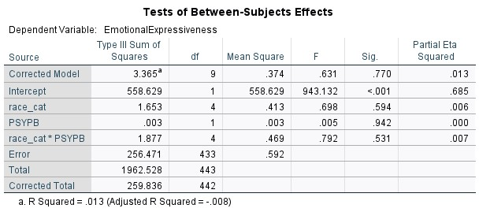

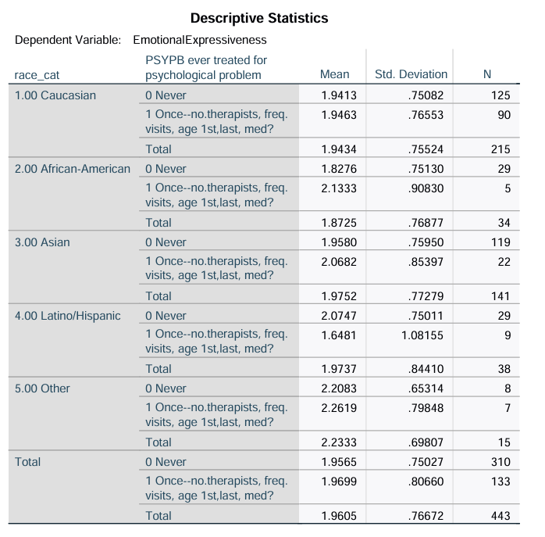

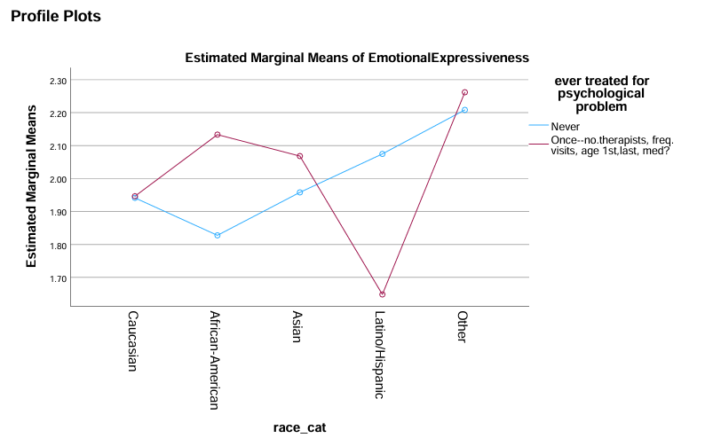

**Analysis 2: Multiple Regressions**

**Justification:**

* This analysis aimed to determine whether Body Confidence and Emotional Dysregulation predict Sexual Exploration. Understanding these relationships can offer insights into psychological factors influencing sexual behavior.

**Design:**

**Independent Variables (IVs):**

* Body Confidence (continuous)
* Emotional Dysregulation (continuous)

**Dependent Variable (DV):**

* Sexual Exploration (continuous)

**Results:**

* The regression model was significant, F(2,471) = 23.468, p < .001, indicating that 9.1% of the variance in Sexual Exploration was explained by Body Confidence and Emotional Dysregulation.
* Body Confidence was a significant predictor (β=.224,t(471)=5.073,p<.001).
* Emotional Dysregulation was also significant (β=.180,t(471)=4.083,p<.001).

**Conclusion:**

* Positive: Both predictors significantly contributed to the model, demonstrating clear relationships with Sexual Exploration.
* Negative: The explained variance (9.1%) is relatively low, suggesting that other factors also influence Sexual Exploration.

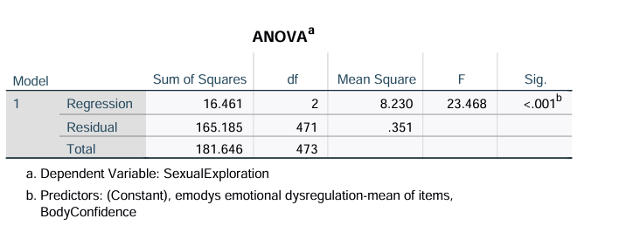

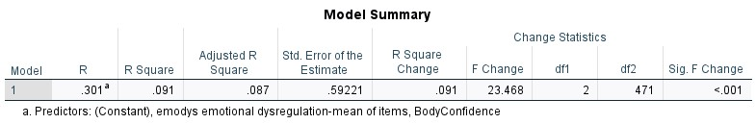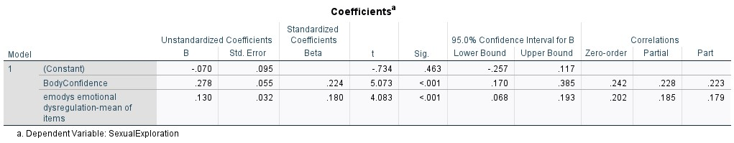

**Analysis 3: One way ANOVA**

**Justification:**

* This analysis assessed whether Emotional Expressiveness differs among individuals with different types of sports participation. It explores the potential emotional benefits of sports involvement.

**Design:**

**Independent Variable (IV):**

* Sports Participation (4 levels: No sports, Non-contact sports, Contact sports, Both)

**Dependent Variable (DV):**

* Emotional Expressiveness (continuous)

**Statistical Analysis Decision:**

* A one-way ANOVA was used to compare the means of Emotional Expressiveness across four different groups and look for significant differences between them.

**Results:**

* The one-way ANOVA was not significant, F(3,311) = 0.489, p = .690, η2 = .005 indicating no significant differences in Emotional Expressiveness among the sports participation groups.
* **Homogeneity of Variance:** Levene’s test was not significant (p>.05), confirming equal variances across groups.

**Conclusion:**

* Positive: The analysis confirmed that the assumptions of the ANOVA were met, ensuring valid results.
* Negative: No significant differences were found, indicating that sports participation type does not significantly impact Emotional Expressiveness.

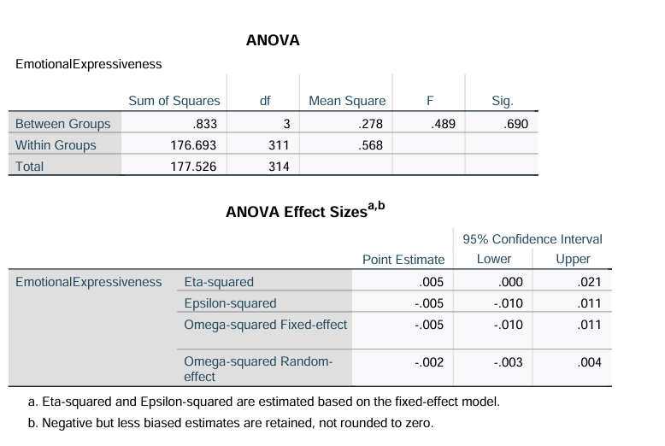

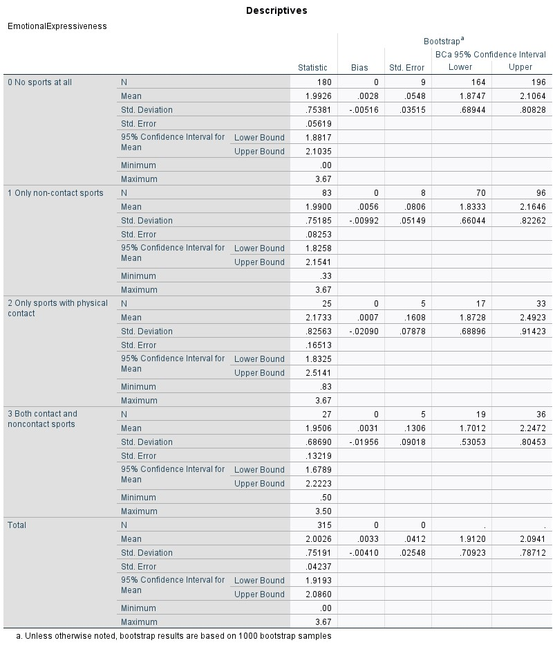

**Discussion**

#### Exploratory Factor Analysis (EFA)

The primary hypothesis was that women’s motivations for sexual aggression differ from men’s, driven by distinct psychological and behavioral constructs. The EFA revealed five factors: **Male Sexual Entitlement**, **Emotional Expressiveness**, **Body Confidence**, **Attention Seeking**, and **Sexual Exploration**. These factors align partially with the hypothesized constructs but also introduce nuances that suggest some overlap with broader behavioral patterns.

**Hypothesis Confirmation**:

The emergence of **Male Sexual Entitlement** supports the idea that women may have motivations related to their expectations of male behavior, aligning with gendered social constructs that differ from traditional male motivations.

**Emotional Expressiveness** and **Body Confidence** highlight psychological dimensions unique to women’s experiences, suggesting emotional and self-perceptual motivations distinct from male-oriented models of aggression.

**Hypothesis Denial**:

The high correlation between **Male Sexual Entitlement** and **Sexual Exploration** indicates overlapping dimensions that challenge the clean separation of motivations. This overlap may reflect shared relational and transactional elements that are not entirely unique to women’s motivations.

#### Validity Analyses

The scales derived from the EFA demonstrated varying degrees of reliability. The factors of **Male Sexual Entitlement**, **Emotional Expressiveness**, **Attention Seeking**, and **Sexual Exploration** were generally reliable and supported the hypothesis. However, the poor reliability of **Body Confidence** (Factor 3) raises questions about its distinctiveness as a construct and its relevance to the hypothesis.

**Hypothesis Confirmation**:

Validity analyses confirm the conceptual integrity of factors representing relational and psychological constructs that differ from traditional male models of sexual aggression.

**Hypothesis Denial**:

The challenges with Factor 3’s reliability and the overlap between Factors 1 and 5 suggest that some motivations may not differ as starkly between genders as hypothesized.

### Limitations of the Study

**Cross-Loadings and Factor Overlap**:

Significant cross-loadings between Factors 1 and 5 and the reliability issues with Factor 3 indicate potential conceptual overlap, limiting the clarity of distinctions between motivations.

**Sample Characteristics**:

The study focused exclusively on undergraduate women, limiting generalizability to broader populations, including different age groups, cultural backgrounds, or men.

**Self-Report Bias**:

The reliance on self-reported data may introduce social desirability bias, particularly in a sensitive topic like sexual aggression, potentially affecting the validity of findings.

**Theoretical Framework**:

While the study was grounded in theoretical constructs, the emergence of unexpected factors suggests the framework may need refinement to fully capture the nuances of women’s motivations for sexual aggression.

**Methodological Constraints**:

The negative reliability of Factor 3 (Body Confidence) indicates possible methodological issues with item selection or measurement, which may have affected the robustness of the factor solution.

**Gender Comparisons**:

While the study hypothesized differences between men’s and women’s motivations, it did not include male participants, limiting direct comparative analysis.

### Conclusion

The findings partially support the hypothesis that women’s motivations for sexual aggression differ from men’s, emphasizing relational and psychological constructs unique to women. However, limitations in reliability, factor overlap, and study design temper these conclusions and highlight areas for further research.